**Period 5**

一、听录音，圈出与所听内容相符的图片。

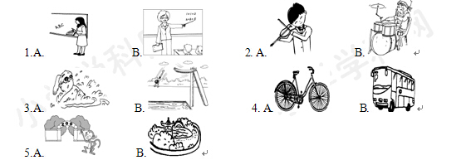

二、用所给单词的正确形式填空。

1. He________（like）collecting stamps.

2. My pen pal________（watch）TV at night.

3. Mike________（go）to work by bus.

4. I like________（make）kites.

5. Mr Bill________(teach)English.

三、选择正确答案。

(　　)1. —How do you go to school？—________

A. I teach English.　　　B. I go by bike.　　　C. I'm going to the park.

(　　)2. ________Miss Li ________math?

A. Does；teaches B. Do；teaches C. Does；teach

(　　)3. They ________ in China.

A. live B. lives C. teaches

(　　)4. My father ________ a singer.

A. are B. am C. is

(　　)5. John likes ________.

A. singing B. sing C. swim

四、根据实际情况回答问题。

1.Is your mother a teacher?

2.Does your mother go to work by bike?

3.Does your father watch TV in the evening?

4.Does your sister go to school by bus?

五、读短文，并将句子补充完整。

Tom is my ________ ________. He is from New York，and now he ________ in Hangzhou. Usually he ________ to school ________ ________. He likes ________ ________ with________ ________.

六、读短文，选择正确答案。

Hello，I'm Liu Yun. Amy is my new pen pal. She lives in America. Her father is a doctor. He goes to work by car. Her mother is a TV reporter. She goes to work by subway. Amy is 12 years old. She likes listening to music. She goes to school by bus. She does homework and reads newspapers every day. Amy says her family is going to London soon to watch the Olympic Games. I'm very excited. I'm going to watch the Olympic Games，too.

(　　)1. Where does Amy live?

A. She lives in America.　　　　　　　B. She lives in England.

(　　)2. How does Amy's mother go to work?

A. She goes to work by car. B. She goes to work by subway.

(　　)3. What is Amy's hobby?

A. She likes listening to music. B. She likes watching TV.

(　　)4. Is Amy coming to England?

A. No，she isn't. B. Yes，she is.

(　　)5. Who will watch the Olympic Games?

A. Amy's family and Liu Yun. B. Amy's family.

**Period 5**

一、1. My mother teaches English.

2. Jerry likes playing the violin.

3. My hobby is diving.

4. Li Lei goes to work by bus.

5. I'm going to the zoo this weekend.

(1～5　A A B B A)

二、1. likes　2. watches　3. goes

4. making　5. teaches

三、1. B　2. C　3. A　4. C　5. A

四、略

五、pen pal，lives，goes，on foot，playing football，his friends

六、1～5　A B A B A